soln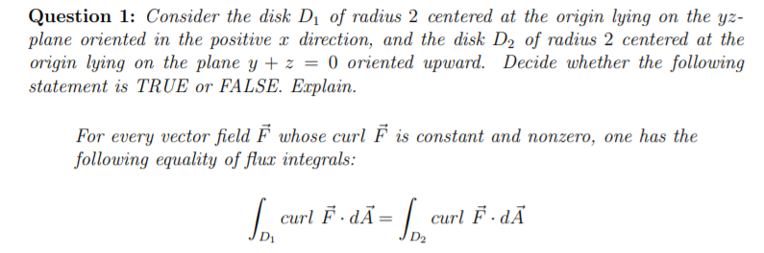

Soln
More precisely, consider the vector field
F = −F2(x, y, z) = −(x, y, z)/||(x, y, z)||3, which is, according to Newton’s law of universal gravitation and up to a multiplicative constant, the force felt by a mass at a point (x, y, z) due to the gravitational attraction of a large mass located at the origin. Suppose we take any path through space so that the distance to the origin is some constant d: that is, we take any path confined to the sphere of radius d. Then the velocity vector at every point lies in the tangent plane to the sphere Sd, and in particular is perpendicular to the purely radial vector field F: in other words, the line integral RC F.

Where C is any curve confined to the sphere Sd, is equal to zero. Thus, the statement is more likely to be true that more is true: suppose we take an arbitrary closed path C (not passing through the origin), e.g. an elliptical orbit. Then the field F need not be perpendicular to the velocity vector at any point, so the integrand of the line integral RC F ・

R is not identically zero, but we nevertheless feel that the work done should come out to be zero. More generally, if we take a path C which is not even necessarily closed (but still not passing through the origin) with initial point P0 = (x0, y0, z0) and P1 = (x1, y1, z1), then we feel that the total work should be given by an expression which depends only on the
Distances d0 = ||(x0, y0, z0)|| and d1 = ||(x1, y1, z1)|| of P0 and P1 from the origin:

If d1 > d2, then the particle ends up farther away than it starts, so energy must be put into the system: the work should be negative. Conversely, if d2 > d1, the particle ends up closer than it started, so energy is released from the system: the work should be positive. And if d1 = d2, energy should be conserved. Since d1= and d2=2 hence d1 =d2 confirming that energy is conserved

Hence the statement is TRUE

